NEWS TRACKER APPLICATION PNT2022TMID03392

IBM DEPLOY IN KUBERNETES CLUSTER

Steps:1

Create a Kubernetes cluster

- Sign in to your IBM Cloud Dashboard.

- Open IBM Kubernetes Service.
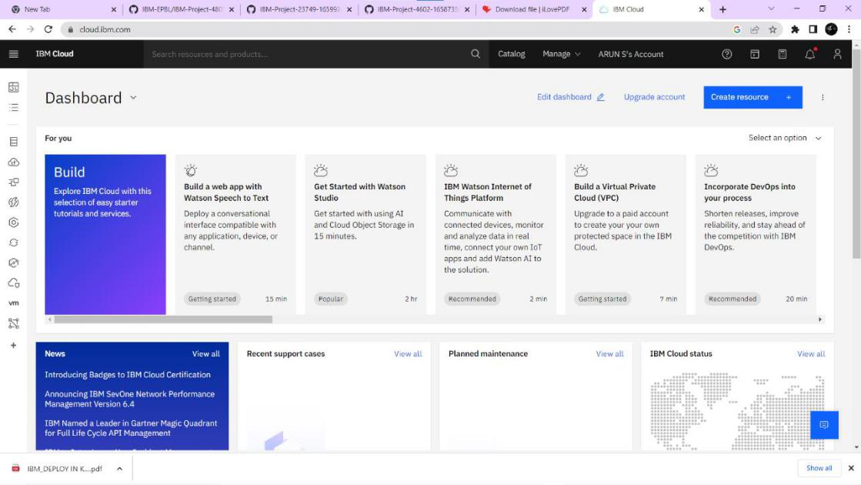

- Click Create Cluster.
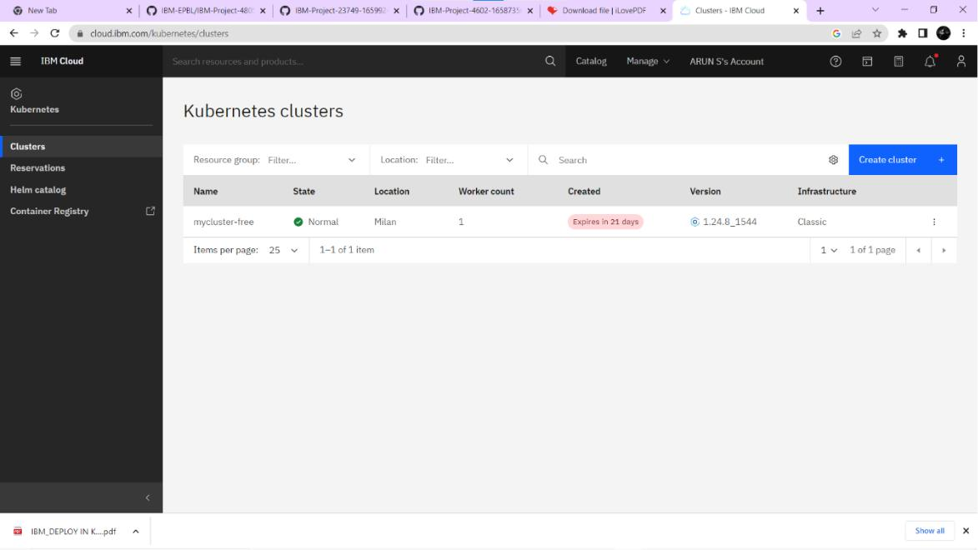

NEWS TRACKER APPLICATION PNT2022TMID03392

- Select the Region where you want to deploy the cluster, type in a name for your cluster, then click Create Cluster.
- Select the appropriate cluster type depending on your account.

- It takes some time for the cluster to get ready (around 30 minutes).
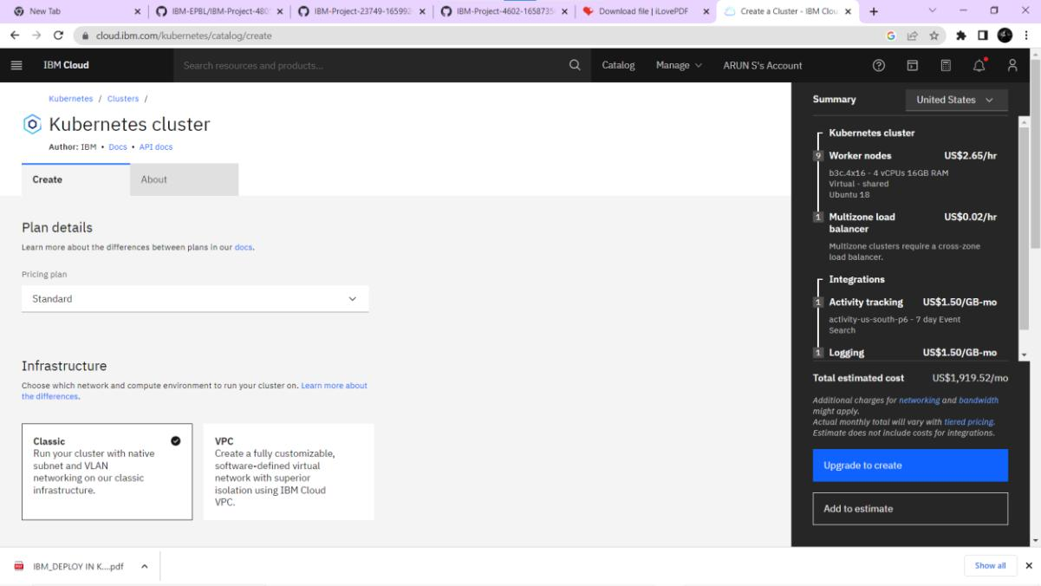

- Once the cluster is ready, click on your cluster's name and you will be redirected to a new page with information about your cluster and worker node.
NEWS TRACKER APPLICATION PNT2022TMID03392
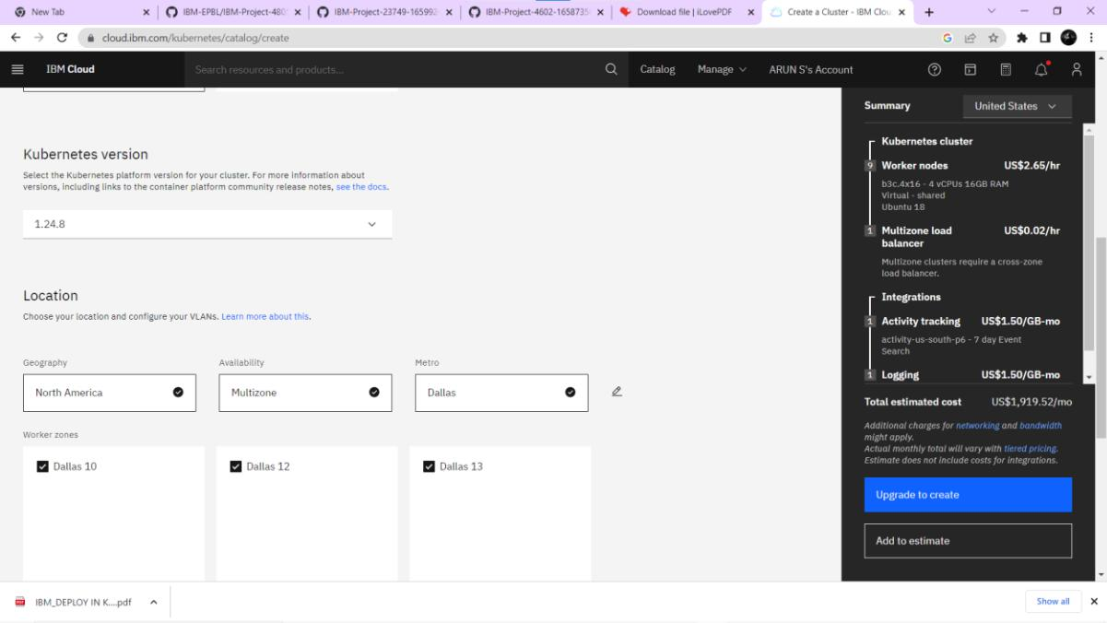

- Click on the Worker Nodes tab to note the cluster's Public IP.
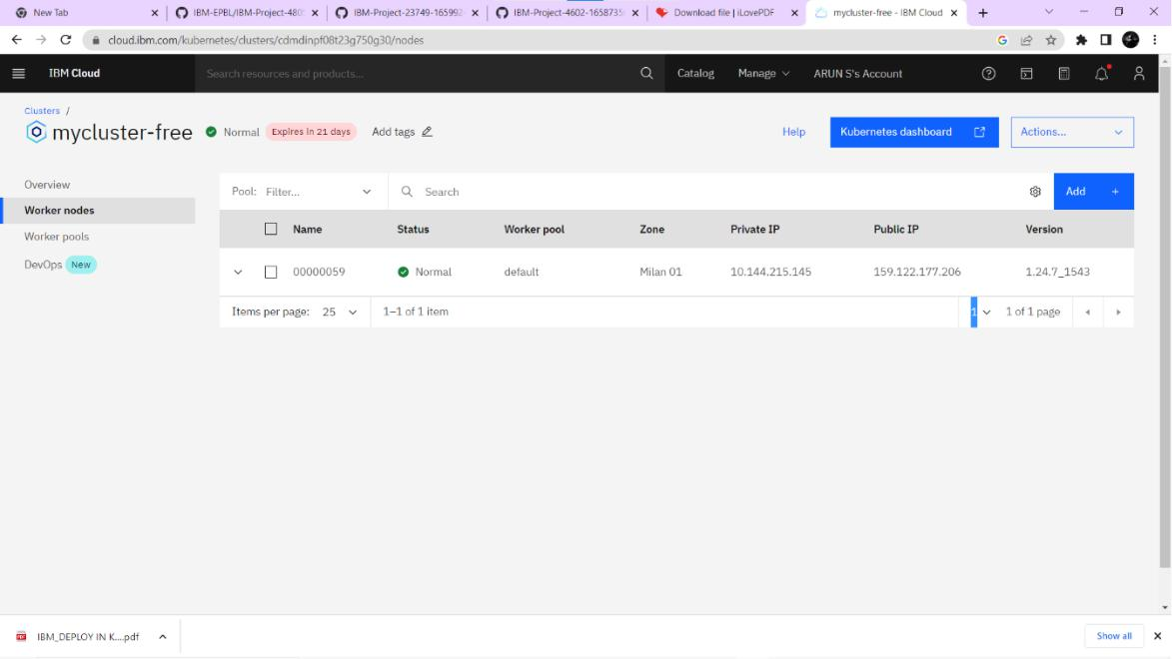

NEWS TRACKER APPLICATION PNT2022TMID03392
